From the Office of Senator Durr
  - 711 N. Main St., Glassboro, nj 08028 phone: 856-595-2676 SenDurr@njleg.org
A note from the Senator:

“Since I was sworn in as a State Senator to represent NJ’s Third Legislative District, I have never wavered on my principles and have always fought for what I believe in. A few key issues are: protecting 2A and the right to bear arms in NJ, preserving parents’ rights to determine what their children are taught and at what grade/age, holding the Governor accountable for pandemic failures, advocating for more trained firefighters and EMTs to effectively extinguish EV fires, and supporting Billy Cray’s Law to allow cameras in group homes so parents of adults with disabilities can be assured of their safety.”
PRESS RELEASE!  June 28, 2023  Durr Opposes Bill Redirecting $1 Billion of Ratepayer relief to Foreign Wind Farm Developer. “(Danish) Orsted is realizing wind farm projects don’t make economic sense without government subsidies…now they’re looking for a handout at the expense of utility customers.” | PRESS RELEASE!  June 2, 2023  Testa & Durr: Despite Democrat Fearmongering, Nobody is Looking to Ban Books. “Age-based rating systems have been used to limit children’s access to mature movies and video games, therefore a similar rating for inappropriate material in school libraries makes sense.” | PRESS RELEASE!  may 31, 2023  Durr Blasts Democrat Bill that Would Punish Schools for Respecting Parental Rights. “We have nearly 200 districts that have suffered devastating cuts under S-2, and now threats of more cuts if districts dare to listen to concerns of parents.”
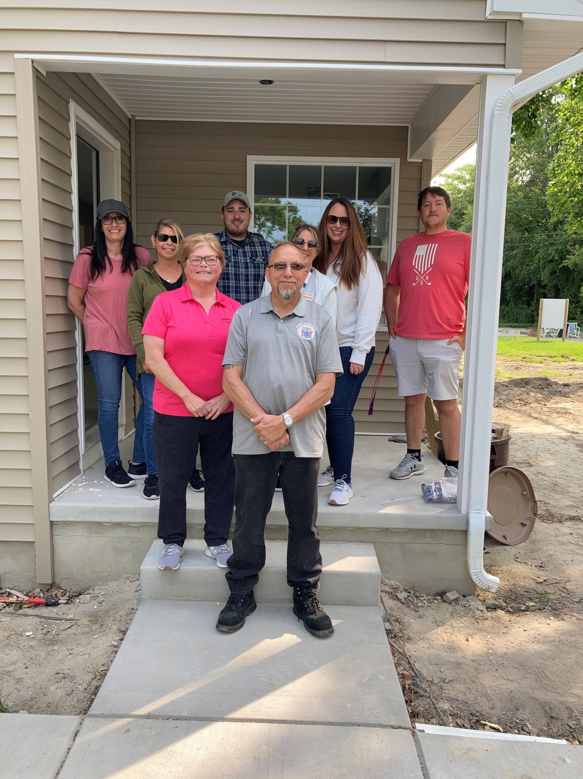 | HABITAT FOR HUMANITY  Salem county  Senator Durr and Assemblywoman McCarthy Patrick and their staff volunteered their time and efforts to assist Habitat for Humanity in the building of a new single-family home in Carneys Point. Habitat for Humanity is a non-profit Christian Housing Ministry that both builds and renovates homes for partner families. Its affiliate, ReStore, offers gently used furniture and appliances to complete the homes. Visit their website at www.habitatsalem.org.
New Judges’ Swearing In  Across the state, there has been a stubbornly high judicial vacancy rate. However, Senator Durr was proud to attend the swearing in of a total of six (6) new judges for our vicinage, bringing our courts back in full working order! Seen in this photo are Judge Niki Arbitter, Senator Durr, and Judge Russell DePersia. Congratulations to all who will work to uphold the law in New Jersey’s courts! | 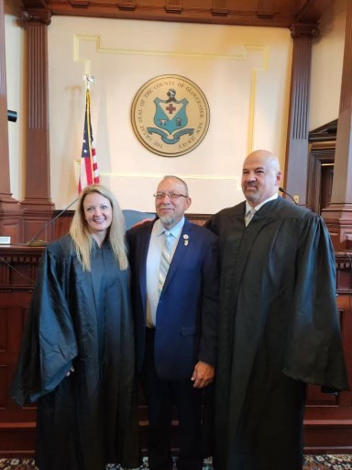
Recognition of Senator Durr by NJSFSC  Senator Durr was graciously awarded the Frank Valenti Award at the New Jersey State Federation Sportsmen’s Clubs 64th annual award banquet at Port-O-Call Hotel in Ocean City. The NJSFSC believes in the importance of conservation education and using our natural resources wisely, while keeping members informed on legislation that can help further its causes. For additional information on NJSFSC, visit the website at www.njsfsc.org. | 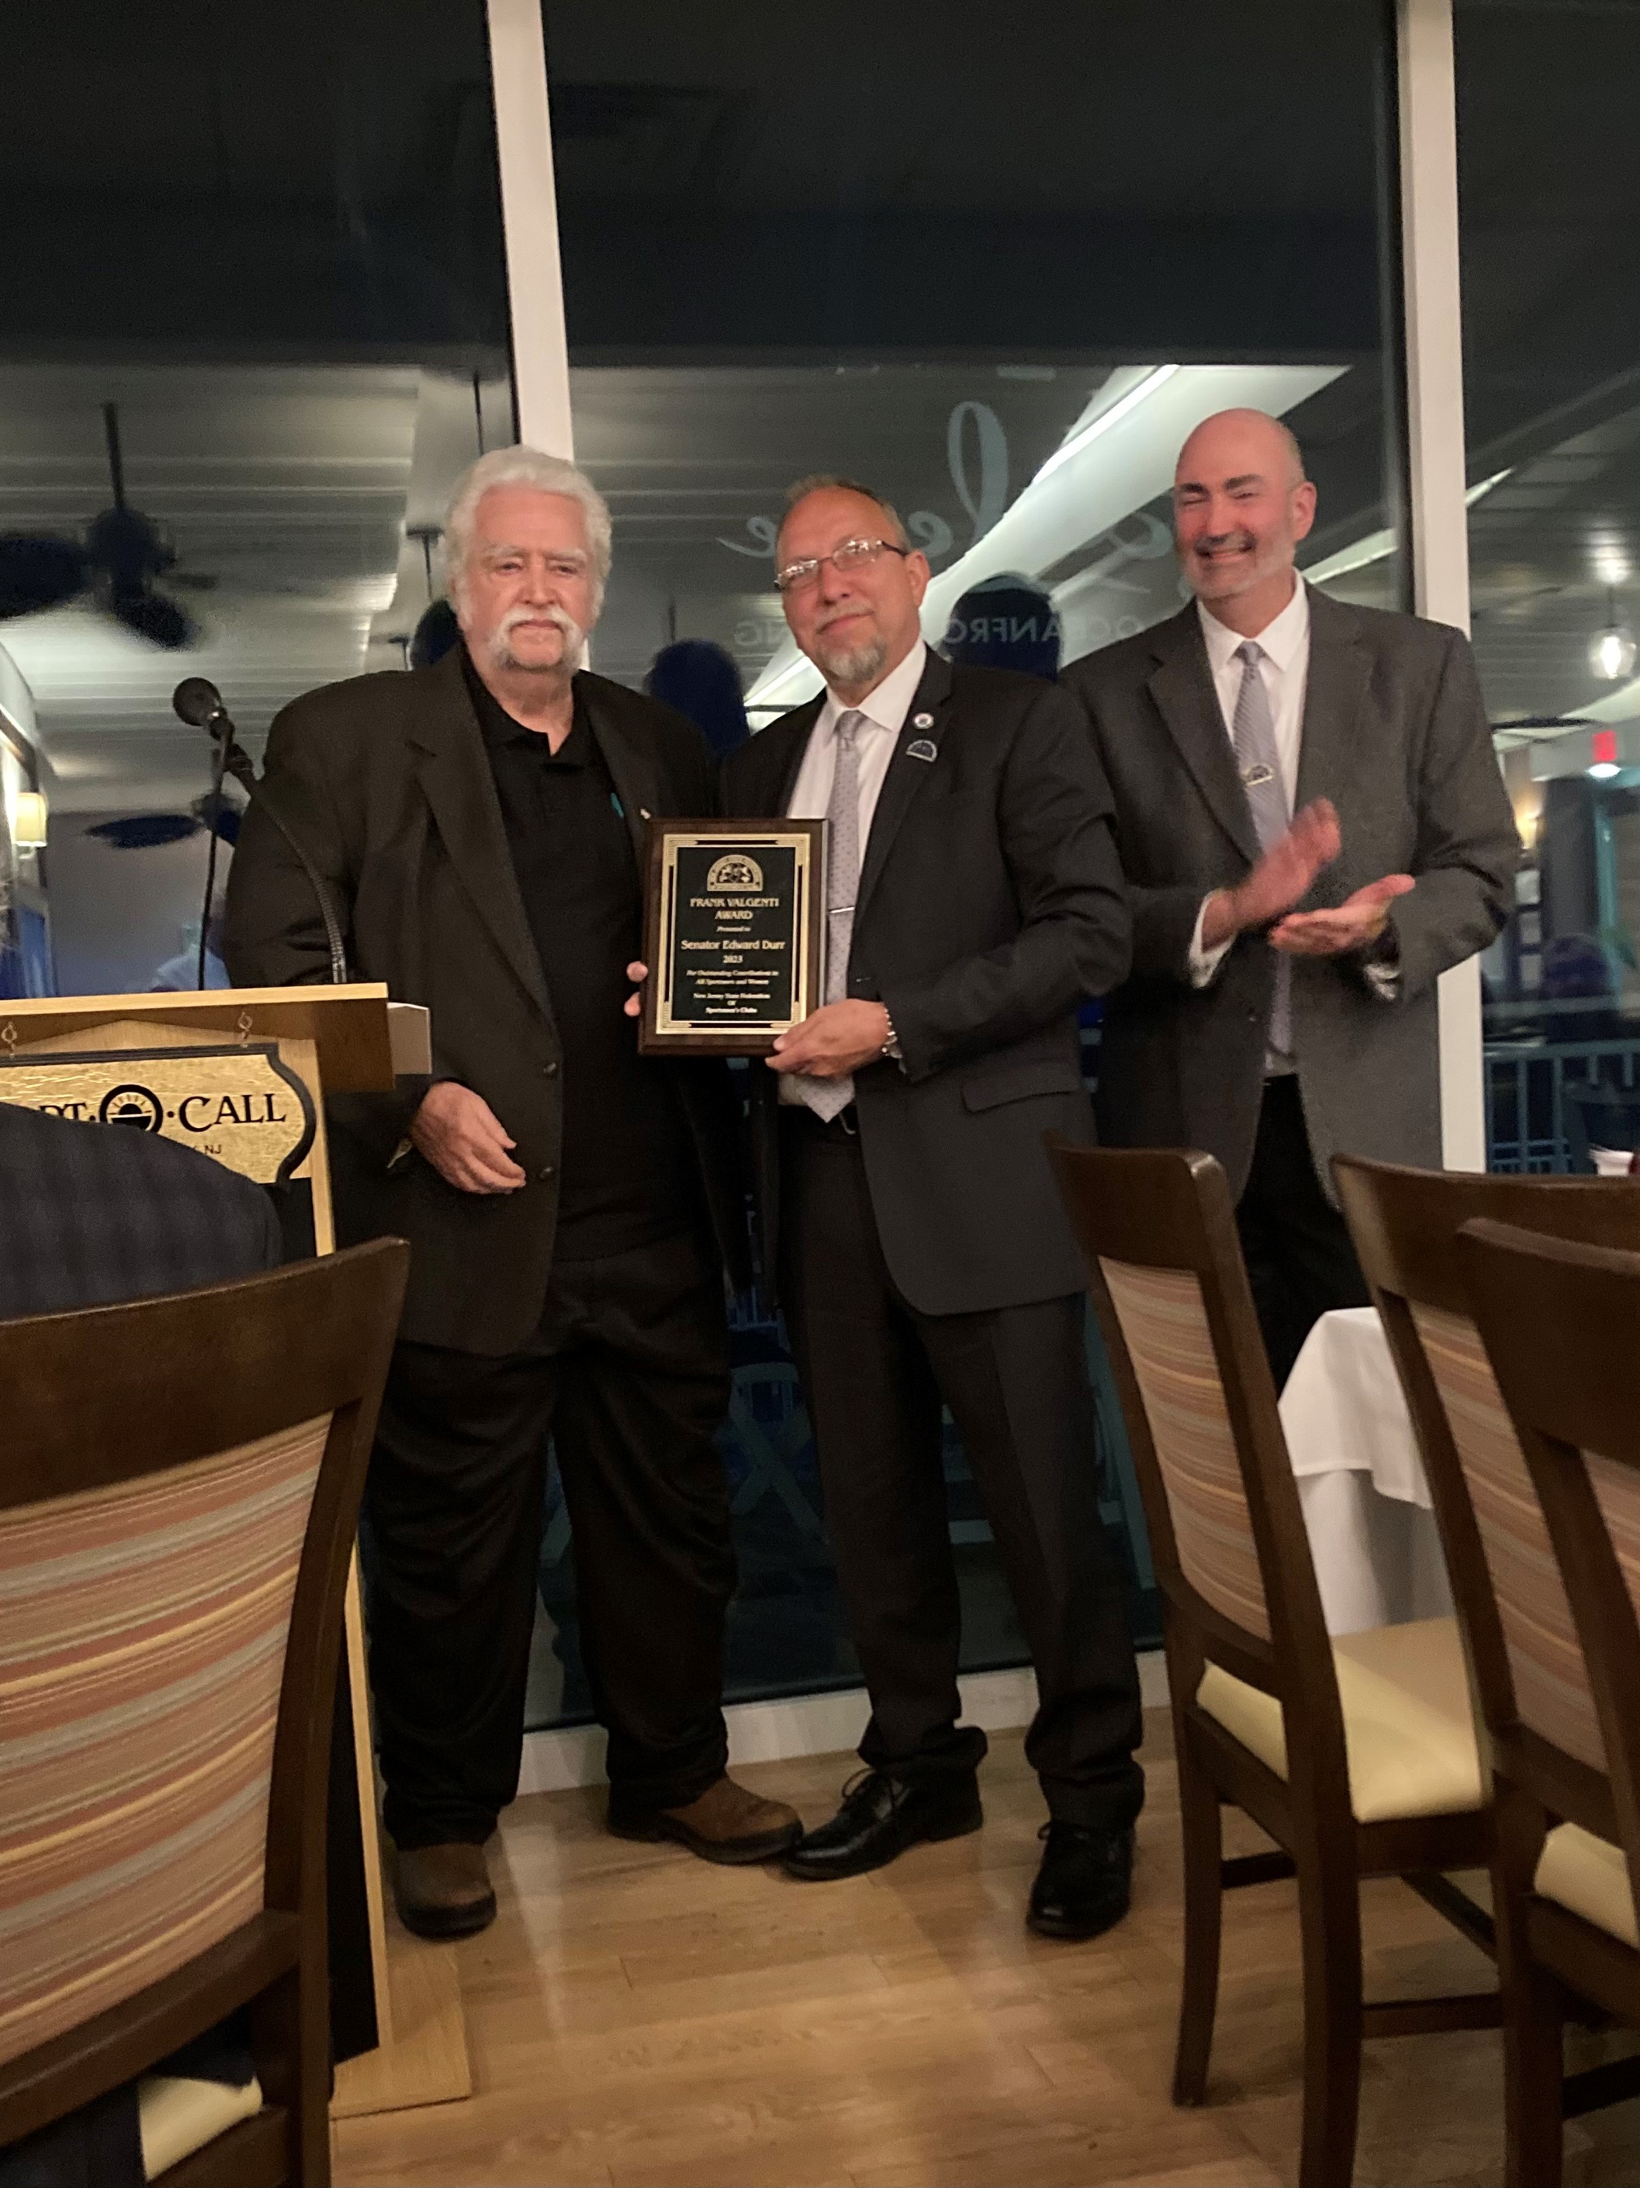
What’s Happening with Senator Durr’s Bills?  See what’s been signed into law as a cosponsor:  S2049: estalishes minimum Medicaid reimbursement rates for brain injury services. S2697: exempts raw honey from Dept. of Health cottage food regulations. S896: prohibits state BOE from requiring completion of performance-based assessment as condition of eligibility for certificate of eligibility. S2426: requires nonpublic & public schools to submit critical incident mapping data to local law enforcement. S715: established Commission on Effects of Social Media Usage on Adolescents to better address mental and emotional needs of students to help improve academic performance. S3241: extends temporary waiver of certain basic life support services & specialty care transport unit crewmember requirements. | 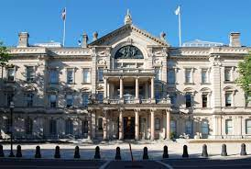
Just a few more things…….
To date, staffers have facilitated NJDOL unemployment claim issues, with 861 resolved and 25 pending. There have been 59 temporary disability claim issues resolved. If you or someone you know resides in LD3 and needs assistance with NJDOL, contact our office at 856-595-2676. Our office also networking with the following agencies on a regular basis:

- MVC (motor vehicles- license, renewals, etc. issues)
- State Department of Treasury & Taxation (ANCHOR, tax return, and pension issues)
- Attorney General’s Office
- DCA (Department of Community Affairs- housing/rent and utility assistance)
- DHS (Department of Human Services)
- DEP (Department of Environmental Protection)
- and all Cumberland, Gloucester & Salem County departments and government offices

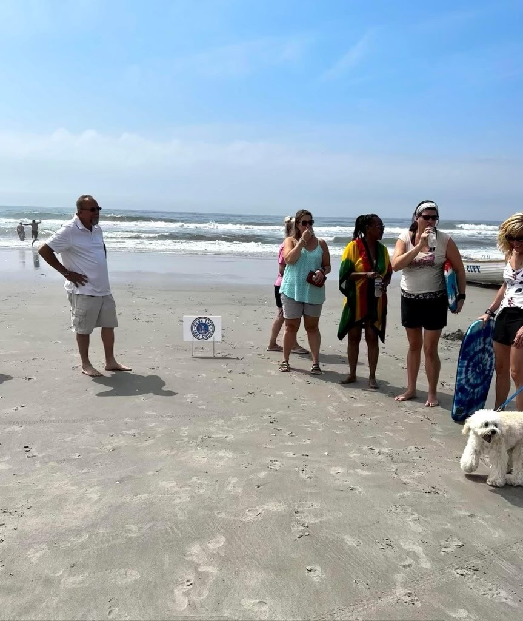
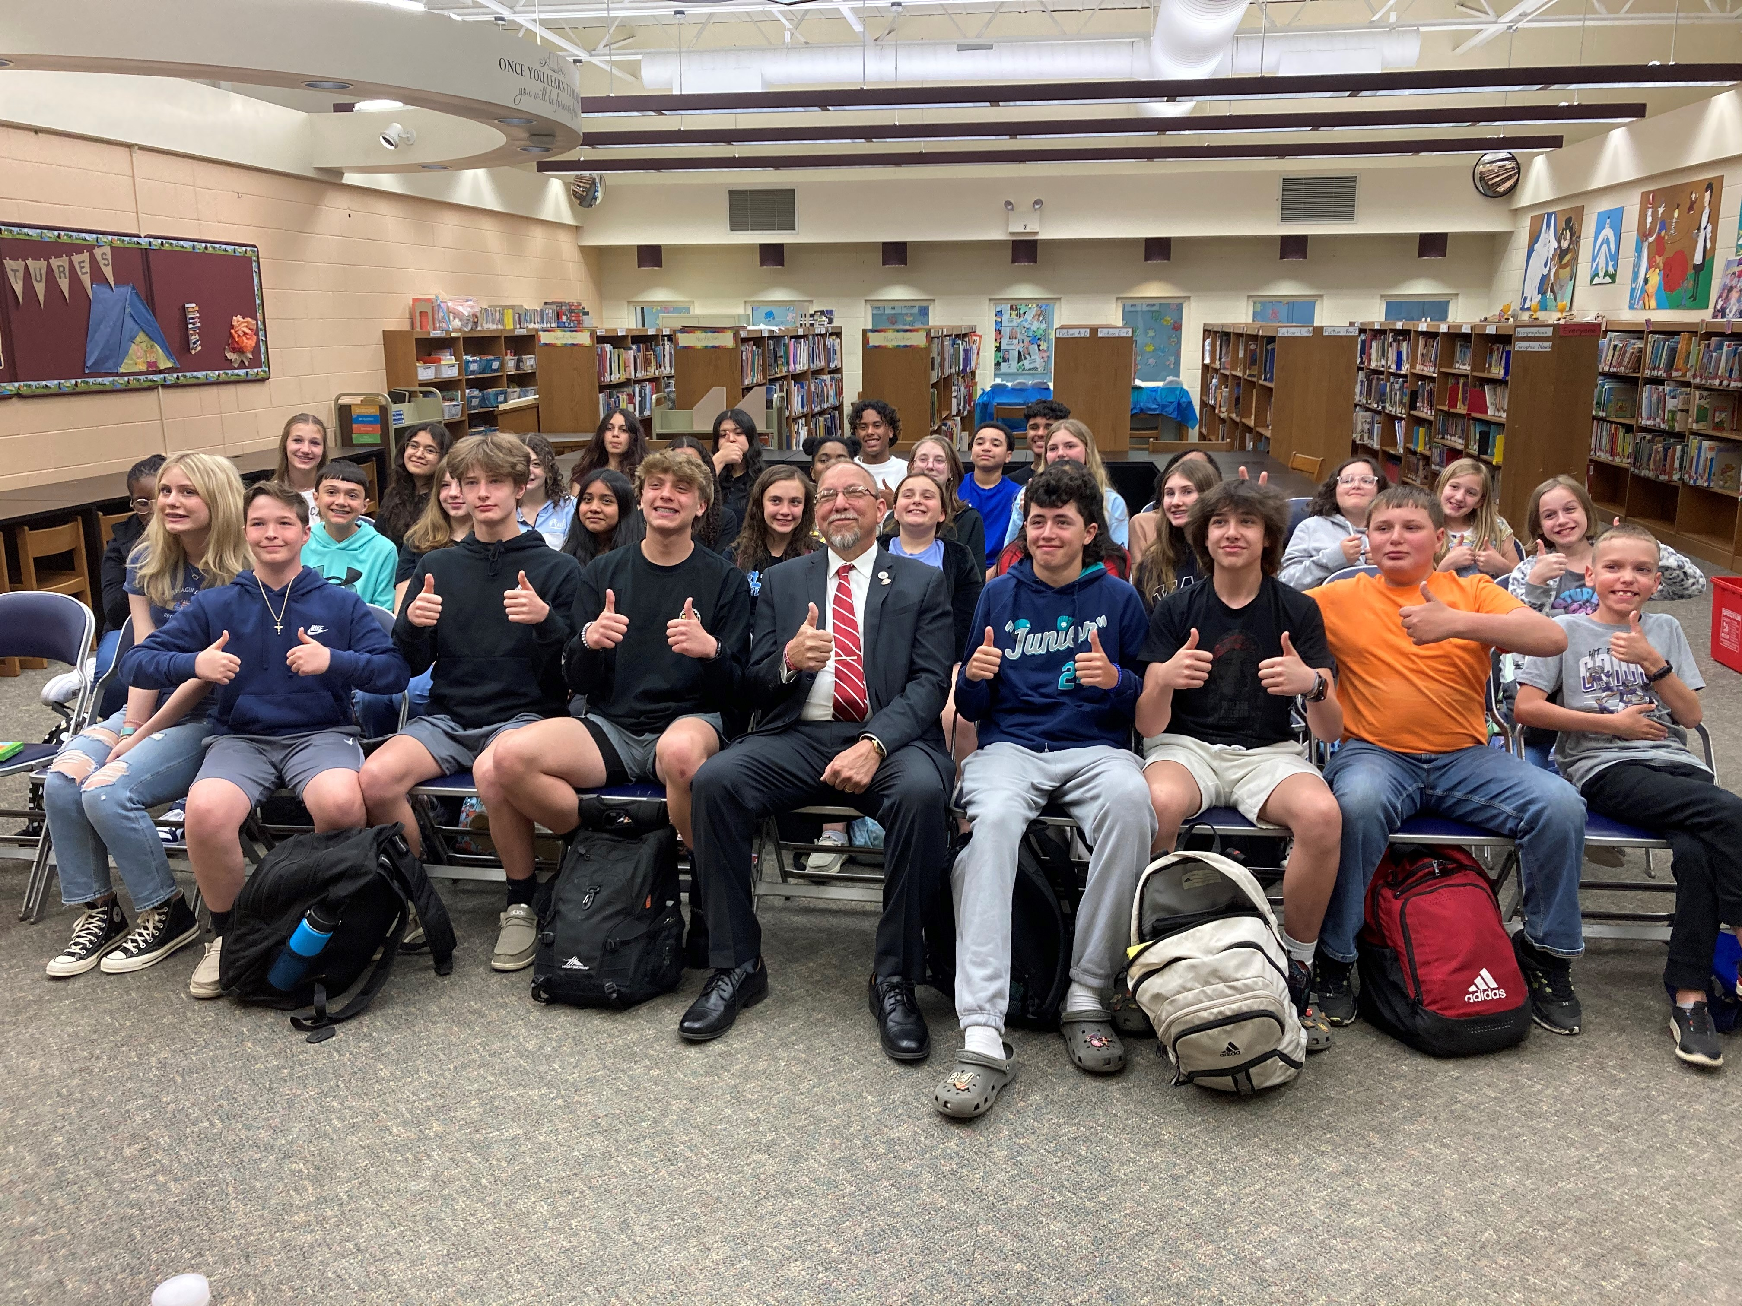
Senator Durr attended the Hands Across the Beach event July 15 in Atlantic City to address issues with the wind turbine development along New Jersey’s coast.
Happy 60th Birthday Senator Durr- July 18, 2023!
Attention Seniors:
2022 Senior Freeze applications are now available! Apply for property tax relief by completing Form PTR-1 (first time) or PTR-2 (previous applicants), which can be obtained online, at your local tax office, or by calling our office for support 856-595-2676. Ask for Maria or Courtney! Deadline is October 31, 2023.
Info: NJ Senior Freeze Hotline 800-882-6597
Senator Durr was warmly welcomed at Deerfield Township School to speak to young and enthusiastic members of the Student Council and NJ Honor Society.
Cost of printing donated, and newsletter was not printed at the taxpayer’s expense.

